Images of the Milky Way @ Bear Spring Camps, Maine

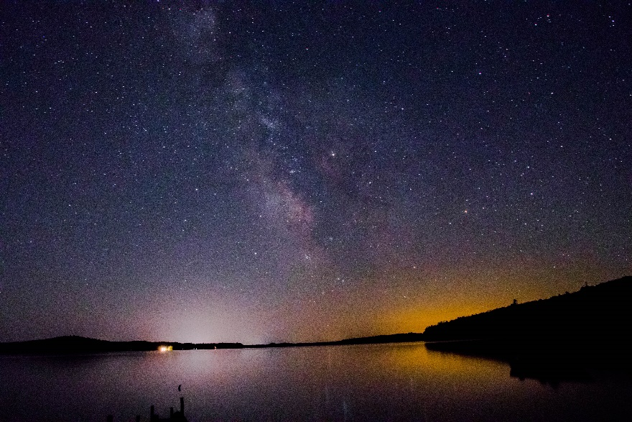Our Spring trip to Bear Springs brought us cool north winds for several days. As the winds left us, clear skies followed and in the early morning of May 21st, our camera and tripod was set up on the shore at Bear Spring Camps, ME at 3 am.   
This is a collection of our first Milky Way photos and our first 2107 night photo session. The photos face south towards the town of Belgrade and a tad of light pollution. And, yes, there was a tad of light painting.

And for the photos, click [Milky Way - Bear Springs](https://goo.gl/photos/x3TEtT3G7b6tQiCe8).